Contributor: Yan Tang, University of Victoria

**Zhou Zuoren (周作人) 1885 – 1967**

Summary

A writer and critic in the New Culture Movement (新文化运动), Zhou Zuoren was one of the most prominent literary figures in the early twentieth century in China. He advocated ‘humanist literature’ (‘人的文学’), arguing that literature should break away from conventions and render true human nature. Zhou was among the first who used vernacular Mandarin (白话) to write poetry and prose. His poems, such as《小河》('A Little River') and 《路上所见》('A Scene on the Road'), were widely praised by Zhu Ziqing (朱自清) and Hu Shi (胡适). Zhou also firmly believed in democracy; he supported individual freedom and social justice, sparing no effort to critique Chinese feudalistic systems and backward superstitions in the 1910s. After the New Culture Movement ended, he left the forefront of political activities. Between 1928 and 1938, he published rather pacifistic essays such as《闭户读书论 》,《哑巴礼赞》, and《麻醉礼赞》. The political controversy around his agreement to working for a pro-Japanese government in the 1930s caused him several years of prison life (Yan 2649-50; Daruvala 4). He returned to Beijing after being released in 1949, and died in 1967 during the Cultural Revolution.

Main Content

The younger brother of Lu Xun (鲁迅; real name: 周树人, Zhou Shuren), Zhou Zuoren was born to a wealthy and traditional family in the city of Shao Xing, Zhe Jiang Province, mainland China, in 1885. He entered Jiangnan Naval Academy in 1901, studying Western technology that required English language and scientific knowledge such as geometry, algebra, and physics. He also read Chinese and Western literature widely. In 1905, he published his first short story 《好花枝》in the magazine 《女子世界》(*Women’s World*; my translation), under a female pseudonym 萍云 (Ping Yun). The short story is about a heroine named 阿珠(Ah Zhu), who miraculously enters a fantasy world and eventually realizes that she is just having a long dream. At the end of the story, Zhou explicitly adds his commentary on the degeneration of the real world and asks readers where the perfect fantasy world would be. His early writing has already suggested his distrust and critique of the chaotic reality where China was undergoing an enormous transition from a feudalistic empire to a semi-colonized, disintegrated, and modernized country at the turn of the twentieth century.

Zhou Zuoren went to Japan in the summer of 1906. During his stay in Japan, he not only studied Japanese language but also devoted himself to translating English and Russian literature into Chinese, which led to the publication of a two-volume anthology《域外小说集》 (*The Anthology of Foreign Fiction*). The anthology includes Chinese translations of fiction by Anton Chekov, Oscar Wilde, Edgar Allan Poe, and Guy de Maupassant among others. Zhou Zuoren also published two long essays,《论文章之意义暨其使命因中国近时论文之失》 and《哀弦篇》, both of which discuss how to revive the national spirit in China and invent new national literature for the ordinary people. In 1909, Zhou Zuoren married the Japanese girl who had taken care of Zhou Zuoren’s and Lu Xun’s accommodation in Japan.

[Insert image here] Caption: the portrait of 28-year-old Zhou Zuoren, photographed in Tokyo, Japan, in 1912.

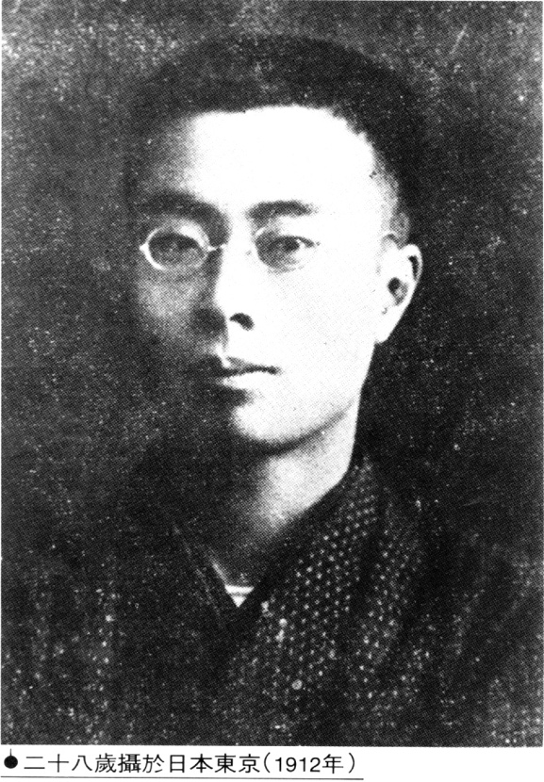

Upon returning to China in the 1910s, Zhou Zuoren was depressed by the social and cultural backwardness of feudalist China. In 1917, Cai Yuanpei (蔡元培), the President of Peking University, invited Zhou Zuoren to teach Chinese literature and compile Chinese history books. Zhou also joined the May Fourth New Culture Movement in 1917 and met Li Dazhao(李大钊), Chen Duxiu (陈独秀), Shen Yinmo (沈尹默), Hu Shi (胡适), and Liu Bannong (刘半农). With the end of the New Culture Movement, Zhou left the forefront of political activities. Between 1928 and 1938, he published rather pacifistic essays such as《闭户读书论 》,《哑巴礼赞》, and《麻醉礼赞》. After Peking (now Beijing) was occupied by the Japanese in 1937, Zhou accepted the position of head librarian at Peking University in January 1939 and joined the State Council in Wang Jingwei's pro-Japanese government (Daruvala 4). This political controversy caused him several years of prison life and led to his silence after 1949 (Yan 2649 50; Daruvala 4). During the Cultural Revolution, Zhou was captured by Red Guards and beaten severely (Daruvala 4). Zhou died on May 6, 1967.

List of works

The following works are translated into English (selected from the bibliography listed on the the MCLC Resource Center: [http://u.osu.edu/mclc/bibliographies/lit/translations-aut/y-z/ - Z](http://u.osu.edu/mclc/bibliographies/lit/translations-aut/y-z/#Z))

‘The Aesthetic Essay’ [Meiwen]

‘Bitter Rain’ [Ku yu]

‘Candy Selling’

‘The Chinese National Character: A Japanese Perspective’

‘An Encounter with Mounted Troops at Qianmen’ [Qianmen yu madui ji]

‘First Love’ [Chu lian]. Tr. Yi Yang. In Woesler, *20th Century Chinese Essays in Translation*. Bochum: Bochum UP, 2000, 27-28.

‘The Fly’ [Cangying]. Tr. Yi Yang. In Woesler, *20th Century Chinese Essays in Translation*. Bochum: Bochum UP, 2000, 20-22.

‘Getting Oneself Hurt.’ Tr. Ernst Wolff. In Wolff, *Chou Tso-jen*. NY: Twayne, 1971, 90-91.

‘How I Translated from the Greek.’ Tr. David Pollard. *Renditions* 7: 16.

‘Humane Literature.’ Tr. Ernst Wolfe. In Wolfe, ed., *Chou Tso-jen*. NY: Twayne, 1971, 97-105; rpt. in Denton, ed., *Modern Chinese Literary Thought*. Stanford: Stanford UP, 1996, 151-61.

‘Japan and China.’ Tr. Richard Rigby.*Renditions* 26: 91-94.

‘Japan Re-encountered.’ Tr. Richard Rigby.*Renditions* 26: 97-106.

‘On ‘Passing the Itch'‘ [Tan guo lai]. Tr. David Pollard. *Renditions* 26: 79-86. Also in Pollard, ed., *The Chinese Essay*. NY: Columbia UP, 2000, 139-49.

‘One’s Own Garden.’ Tr. Ernst Wolff. In Wolff, *Chou Tso-jen*. NY: Twayne, 1971, 95-97.

‘In Praise of Mutes’ [Yaba lizan]. Tr. David Pollard. *Renditions* 26: 76-78. Also in Pollard, ed., *The Chinese Essay*. NY: Columbia UP, 2000, 156-59.

‘Requisites for a New Literature.‘ [Xin wenxue de yaoqiu]. Tr. Kirk A. Denton. MCLC Resource Center Publication (Oct. 2000).

*Selected Essays by Zhou Zuoren*. Tr. David Pollard. HK: Chinese University Press, 2005. [[MCLC Resource Center review by Geoges Be Duc](http://u.osu.edu/mclc/book-reviews/selected-essays-of-zhou-zuoren/)]

‘Relentless Rain’ [Ku yu]. Tr. David Pollard. In Pollard, ed., *The Chinese Essay.* NY: Columbia UP, 2000, 131-35.

‘The Tea Pastries of Peking’ [Beijing de chashi]. Tr. Jin Li. In Woesler, *20th Century Chinese Essays in Translation*. Bochum: Bochum UP, 2000, 15-16.

‘The Way to Die.’ Tr. Paula Chin and Rebecca Kwan.*Journal of Asian Culture* (1977): 24-35.

‘Wild Vegetable of My Home Region’ [Guxiang de yecai]. Tr. Martin Woesler. In Woesler, *20th Century Chinese Essays in Translation*. Bochum: Bochum UP, 2000, 17-19.

‘Women and Literature.’ Tr. Michelle Yeh. In Denton, ed., *Modern Chinese Literary Though*t. Stanford: Stanford UP, 1996, 228-32.

Poems in: *Modern Chinese Poetry*. Trs. Harold Acton and Chen Shih-hsiang. London: Duckworth, 1936.

Further Reading

Yan, Lu. ‘Zuoren, Zhou.’ *Berkshire Encyclopedia of China*: *Modern and Historic Views of the World's Newest and Oldest Global Power*. Vol. 5. Great Barrington, MA: Berkshire Publishing, 2009. 2648-2650. *Gale Virtual Reference Library*. Web. 13 June 2016.

Susan Daruvala. *Zhou Zuoren and an Alternative Chinese Response to Modernity*. Cambridge: the Harvard University Asia Center, 2000. Print.

Qian Linqun. *Zhou Zuo ren zhuan [The Biography of Zhou Zuoren].* Beijing: Beijing shi yue wen yi chu ban she, 2001. Print.

Zhang, Wei. ‘Zhou Zuoren and the Uses of Ancient Greek Mythology in Modern China.’ *International Journal of the Classical Tradition* 22.1 (2015): 100-15. *Academic Search Complete*. Web. 2 July 2016.

Frederik H. Green. ‘Translating poetic modernity: Zhou Zuoren's interest in modern Japanese poetry.’ *Journal of Modern Literature in Chinese*, 11.1 (2013): 138. *Literature Resource Center*. Web. 2 July 2016.

Li, Tonglu. ‘The Sacred and the Cannibalistic: Zhou Zuoren's Critique of Violence in Modern China.’ *Chinese Literature, Essays, Articles, Reviews*, 36 (2014): 25-60. *ProQuest Literature Online*. Web 2 July 2016.